|  |  |
| --- | --- |
|  |  |
| Final Project Part 1 |  |
|  |  |
|  | 11/19/20  EGR-7040 |
|  | JACK YOUNG |

Table of Contents

Table of Figures 2

Problem Description 3

[Figure 1: Shows problems outlined by assignment 3](https://raidermailwright-my.sharepoint.com/personal/young_330_wright_edu/Documents/School/Fall%20Semester%202020%20-%20Masters%20Mechanical%20Engineering/EGR%207040/Homework/Homework6/Homework%206%20report.docx#_Toc56719939)

1 – Steepest Descent and Golden Section Method 4

[Figure 2: Search algorithm behavior or Golden Section with Steepest Descent 4](https://raidermailwright-my.sharepoint.com/personal/young_330_wright_edu/Documents/School/Fall%20Semester%202020%20-%20Masters%20Mechanical%20Engineering/EGR%207040/Homework/Homework6/Homework%206%20report.docx#_Toc56719941)

2 – Conjugate Gradient and Golden Section Method 5

[Figure 3: Search algorithm behavior for Conjugate Gradient method and Polynomial Interpolation method 5](https://raidermailwright-my.sharepoint.com/personal/young_330_wright_edu/Documents/School/Fall%20Semester%202020%20-%20Masters%20Mechanical%20Engineering/EGR%207040/Homework/Homework6/Homework%206%20report.docx#_Toc56719943)

3 – Conjugate Gradient and Polynomial Interpolation Method 6

[Figure 4: Search algorithm behavior for Conjugate Gradient and Polynomial Interpolation method 6](https://raidermailwright-my.sharepoint.com/personal/young_330_wright_edu/Documents/School/Fall%20Semester%202020%20-%20Masters%20Mechanical%20Engineering/EGR%207040/Homework/Homework6/Homework%206%20report.docx#_Toc56719945)

4 – Modified Newton and Polynomial Interpolation Method 7

[Figure 5: Search algorithm behavior for Modified Newton’s method and Polynomial Interpolation method 7](https://raidermailwright-my.sharepoint.com/personal/young_330_wright_edu/Documents/School/Fall%20Semester%202020%20-%20Masters%20Mechanical%20Engineering/EGR%207040/Homework/Homework6/Homework%206%20report.docx#_Toc56719947)

5 – Modified Newton and Inexact Armijo Method 8

[Figure 6: Search algorithm behavior for Modified Newton’s method and Inexact Armijo method 8](https://raidermailwright-my.sharepoint.com/personal/young_330_wright_edu/Documents/School/Fall%20Semester%202020%20-%20Masters%20Mechanical%20Engineering/EGR%207040/Homework/Homework6/Homework%206%20report.docx#_Toc56719949)

6 – Conclusions 9

Appendix A: Code 10

# Table of Figures

[Figure 1: Shows problems outlined by assignment 3](https://raidermailwright-my.sharepoint.com/personal/young_330_wright_edu/Documents/School/Fall%20Semester%202020%20-%20Masters%20Mechanical%20Engineering/EGR%207040/Homework/Homework6/Homework%206%20report.docx#_Toc56719953)

[Figure 2: Search algorithm behavior or Golden Section with Steepest Descent 4](https://raidermailwright-my.sharepoint.com/personal/young_330_wright_edu/Documents/School/Fall%20Semester%202020%20-%20Masters%20Mechanical%20Engineering/EGR%207040/Homework/Homework6/Homework%206%20report.docx#_Toc56719954)

[Figure 3: Search algorithm behavior for Conjugate Gradient method and Polynomial Interpolation method 5](https://raidermailwright-my.sharepoint.com/personal/young_330_wright_edu/Documents/School/Fall%20Semester%202020%20-%20Masters%20Mechanical%20Engineering/EGR%207040/Homework/Homework6/Homework%206%20report.docx#_Toc56719955)

[Figure 4: Search algorithm behavior for Conjugate Gradient and Polynomial Interpolation method 6](https://raidermailwright-my.sharepoint.com/personal/young_330_wright_edu/Documents/School/Fall%20Semester%202020%20-%20Masters%20Mechanical%20Engineering/EGR%207040/Homework/Homework6/Homework%206%20report.docx#_Toc56719956)

[Figure 5: Search algorithm behavior for Modified Newton’s method and Polynomial Interpolation method 7](https://raidermailwright-my.sharepoint.com/personal/young_330_wright_edu/Documents/School/Fall%20Semester%202020%20-%20Masters%20Mechanical%20Engineering/EGR%207040/Homework/Homework6/Homework%206%20report.docx#_Toc56719957)

[Figure 6: Search algorithm behavior for Modified Newton’s method and Inexact Armijo method 8](https://raidermailwright-my.sharepoint.com/personal/young_330_wright_edu/Documents/School/Fall%20Semester%202020%20-%20Masters%20Mechanical%20Engineering/EGR%207040/Homework/Homework6/Homework%206%20report.docx#_Toc56719958)

# Problem Description

The work given for this project can be described by Figure 1.

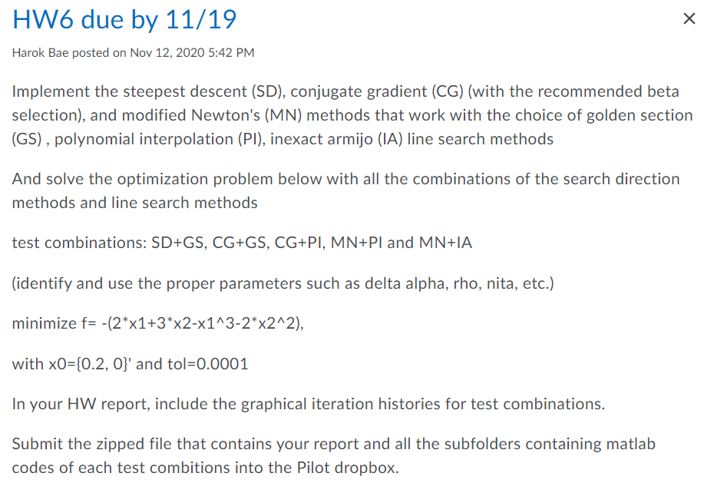

## Figure : Shows problems outlined by assignment

These requirements involved:

• 1 – Steepest descent method and golden section method

• 2 – Conjugate gradient and golden section method

• 3 – Conjugate gradient and polynomial interpolation method

• 4 – Modified newton and polynomial interpolation method

• 5 – Modified newton and inexact Armijo method

• 1-5 are to show graphical iterative histories for the test combinations of the given minimization function in Figure 1

# 1 – Steepest Descent and Golden Section Method

The steepest descent method was implemented in python with the search direction determined by the golden section method. The search path taken by the algorithm has been plotted below in Figure 2. The starting point of xk = [.5,0] was used as requested. The search finished after 6 iterations at a final xk shown in Figure 2. The total time for execution of the search portion of the code was 58.1 milliseconds. This method used 6 iterations to complete.

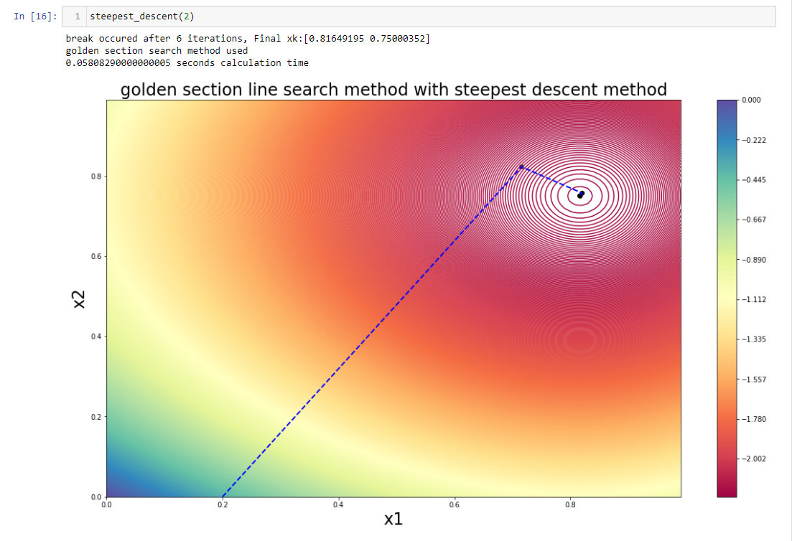

## Figure : Search algorithm behavior or Golden Section with Steepest Descent

# 2 – Conjugate Gradient and Golden Section Method

The conjugate gradient method was applied using the conjugate gradient method using the golden section method for search direction alpha k. Additionally, at starting xk = [.5,0] and followed a similar but slightly different search path as can be seen below in Figure 3. This behavior is rather similar compared with the behavior seen in Figure 2; however, the conjugate gradient method finds the optimum point in a longer amount of time 72.9 milliseconds of algorithm execution time. This method used 6 iterations to complete.

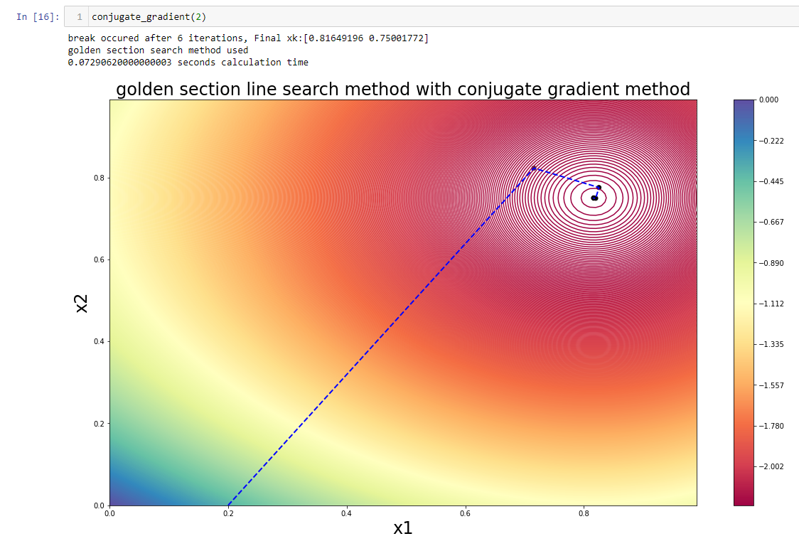

## Figure : Search algorithm behavior for Conjugate Gradient method and Polynomial Interpolation method

# 3 – Conjugate Gradient and Polynomial Interpolation Method

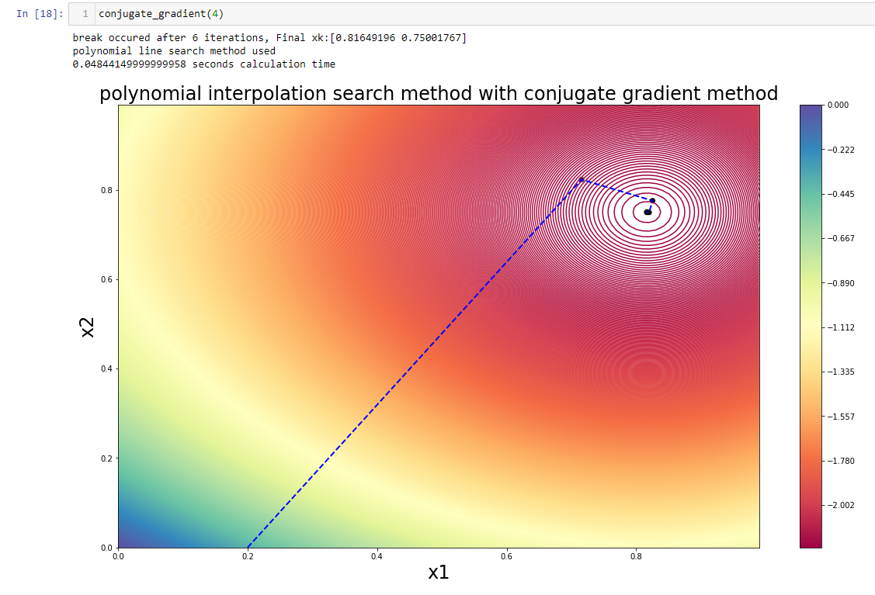 The conjugate gradient method was applied a second time this time using a different methodology for determination of the search direction alpha k. This methodology used the same starting xk point as all the other graphs. An execution time of 48.4 milliseconds is better than that seen from all the others and for this particular minimum point and start location appears to be better than those shown in Figure 2 and Figure 3. This methodology also only took 6 iterations to complete.

## Figure : Search algorithm behavior for Conjugate Gradient and Polynomial Interpolation method

# 

# 4 – Modified Newton and Polynomial Interpolation Method

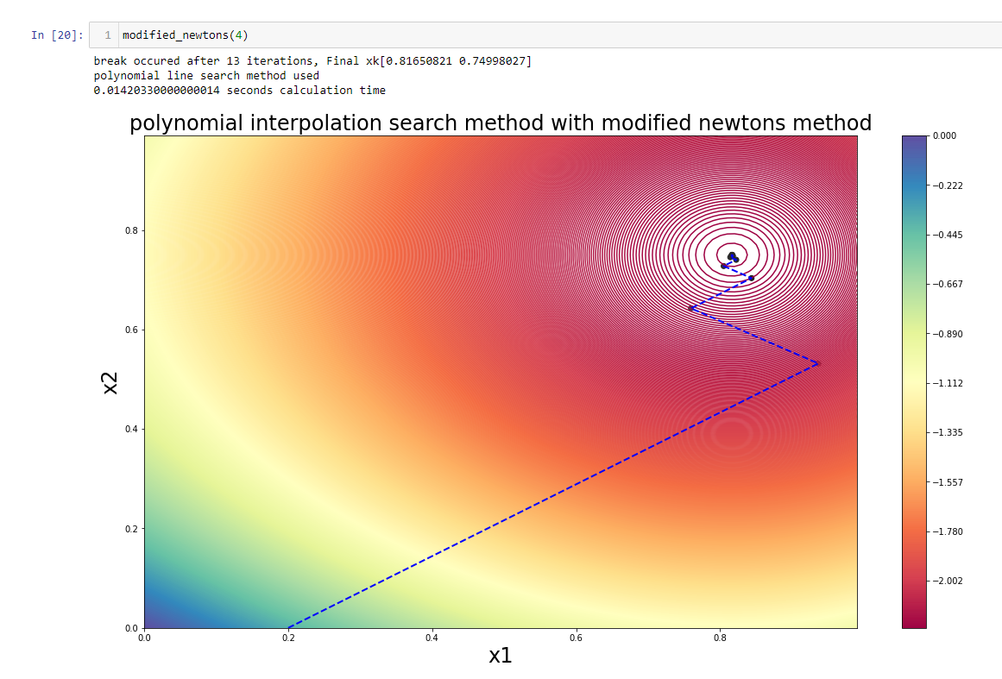 The next minimum point search implementation involved the modified newton’s method and polynomial interpolation methodologies. These methodologies produced a much longer search path than the other methods. This method took 13 iterations to complete but executed faster anyways and only took a mere 14.2 milliseconds making it the fastest method combo for finding this minimum point yet. These results can be seen below in Figure 5.

## Figure : Search algorithm behavior for Modified Newton’s method and Polynomial Interpolation method

# 5 – Modified Newton and Inexact Armijo Method

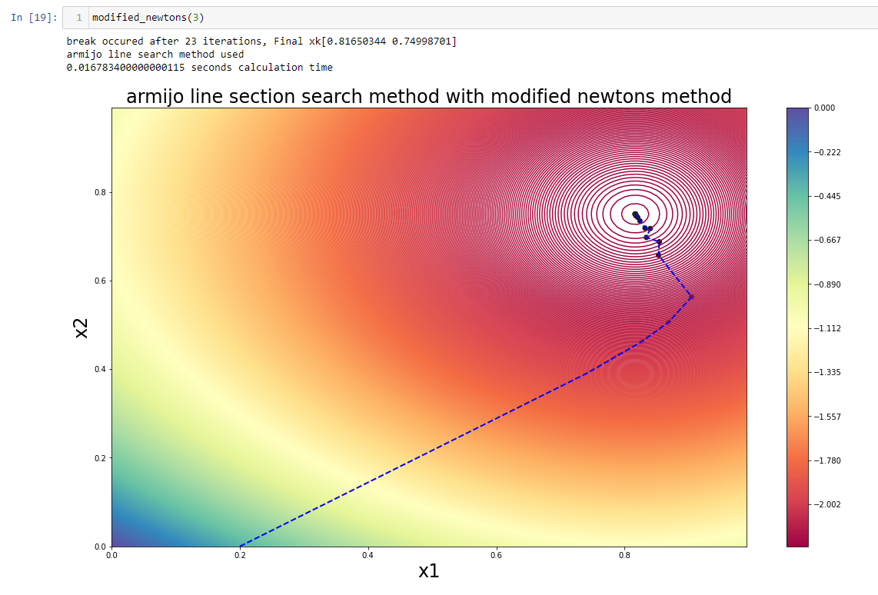The last search algorithm methodology combo was the modified newton’s method and the inexact Armijo method. This method has the most unique search path of all the search paths graphed during this homework 6 report. The search path can be seen below in Figure 6 and can be seen to have a search direction change behavior that is much different than the other methodologies search direction behaviors. This method converged to a minimum point after 23 iterations and 16.7 milliseconds making it the second fastest studied.

## Figure : Search algorithm behavior for Modified Newton’s method and Inexact Armijo method

# 6 – Conclusions

In conclusion, of the methodologies studied they all were able to converge on the minimum point of x=[.8165, .7500]. The convergence to the correct minimum point reflects the consistent nature of the methodologies studied. From a practical standpoint from the data shown in:

Figure 2: Search algorithm behavior or Golden Section with Steepest Descent

Figure 3: Search algorithm behavior for Conjugate Gradient method and Polynomial Interpolation method

Figure 4: Search algorithm behavior for Conjugate Gradient and Polynomial Interpolation method, Figure 5: Search algorithm behavior for Modified Newton’s method and Polynomial Interpolation method

Figure 6: Search algorithm behavior for Modified Newton’s method and Inexact Armijo method.

We can say that there is not much difference in the practical use of each one of these algorithms over another unless they need to be run many many times. If this is the case and we need many cycles we should choose the conjugate gradient method paired with another method as it converges faster in our tests in python Jupyter notebook.

# Appendix A: Code

A GitHub repository containing the code for this project can be accessed at the link provided:

Python was used to write the code for the project.